ISSN – 2550 – 8032

CERTIFICATE OF ACCEPTANCE

**Lokoja Journal of Applied Sciences**

**(LOJAS)**

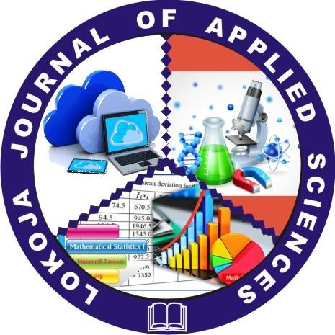

THIS IS TO CERTIFY THAT OUR REVIEW BOARD HAS ACCEPTED RESEARCH PAPER OF

**SHEIDU AUDU YAKUBU**

**TITLED: TASK SCHEDULLING CHALLENGES IN CLOUD COMPUTING ENVIRONMENT.**

 __________________

**September, 2020** **Dr. Ayodele O.S.**

***Associate Editor***

ISSN – 2550 – 8032

CERTIFICATE OF ACCEPTANCE

**Lokoja Journal of Applied Sciences**

**(LOJAS)**



THIS IS TO CERTIFY THAT OUR REVIEW BOARD HAS ACCEPTED RESEARCH PAPER OF

**SHEIDU AUDU YAKUBU**

**TITLED: DESIGN AND IMPLEMENTATION OF AN AUTOMATED RESULT SHEET FOR NIGERIA POLYTECHNIC.**



**September, 2020** **Dr. Ayodele O.S.**

***Associate Editor***